**Project Database Design**

**Hotel – Room Service**

***Team:***

***Patrut Anita – Alexandra***

***Iorga Adina***

***Petrisor Paul - Andrei***

**TABLES**

* **The Client Table**

CREATE TABLE Client(

ID INTEGER PRIMARY KEY,

Name VARCHAR2(80) NOT NULL,

GENDER CHAR NOT NULL

);

* **The Room Table**

CREATE TABLE Room(

ID INTEGER PRIMARY KEY,

Working_day_price NUMBER(7,2) NOT NULL,

Weekend_price NUMBER(7,2) NOT NULL,

No_of_places INTEGER NOT NULL

);

* **The Reservation Table**

CREATE TABLE Reservation(

Client_ID INTEGER,

Room_ID INTEGER,

Start_Date Date NOT NULL,

End_Date Date NOT NULL,

Fee NUMBER(7,2) NOT NULL,

CONSTRAINT fk_client FOREIGN KEY (Client_ID) REFERENCES Client(ID),

CONSTRAINT fk_room FOREIGN KEY (Room_ID) REFERENCES Room(ID)

);

**REQUIREMENTS**

1. **Write an SQL file to create the database structure and define all necessary Key Constraints. Add to this file also some INSERT statements to add at least ten clients and ten hotel rooms.**

INSERT ALL INTO Client VALUES (1,'Tori Koch','F')

INTO Client VALUES (2,'Dane Mclean','M')

INTO Client VALUES (3,'Roselyn Arellano','F')

INTO Client VALUES (4,'Pamela Nash','F')

INTO Client VALUES (5,'Bo Dyer','M')

INTO Client VALUES (6,'Tamia Bush','F')

INTO Client VALUES (7,'Gracelyn Barry','F')

INTO Client VALUES (8,'Averi Lutz','M')

INTO Client VALUES (9,'Hayden Green','M')

INTO Client VALUES (10,'Camilla Dennis','F')

INTO Client VALUES (11,'Steve Grant','M')

INTO Client VALUES (12,'Porter Warner','M')

INTO Client VALUES (13,'Olive Hurley','M')

INTO Client VALUES (14,'Yareli Bautista','F')

INTO Client VALUES (15,'Isabela Douglas','F')

SELECT * FROM dual;

INSERT ALL INTO Room VALUES (100,120,140,2)

INTO Room VALUES (101,120,140,2)

INTO Room VALUES (102,100,120,2)

INTO Room VALUES (103,100,120,2)

INTO Room VALUES (104,100,120,2)

INTO Room VALUES (105,120,140,2)

INTO Room VALUES (106,160,180,1)

INTO Room VALUES (107,160,180,1)

INTO Room VALUES (108,160,180,1)

INTO Room VALUES (109,100,120,1)

INTO Room VALUES (110,180,200,2)

INTO Room VALUES (111,180,200,2)

SELECT * FROM dual;

1. **Write a stored procedure for booking a room. The current date will be used as start date, while the rest of necessary information is passed by parameters (Client_ID, Room_ID. No_of_days). The No_of_days will be used to compute the agreed End_date. The procedure has to compute the fee based on Working_days_price and Weekend_price from the Room table.**

CREATE OR REPLACE PROCEDURE Book_a_room(Client_ID IN Client.ID%Type,

Room_ID IN Room.ID%Type,

No_of_Days IN INTEGER) IS

Start_Date Date;

End_Date Date;

No_of_Working_Days INTEGER;

No_of_Weekend_Days INTEGER;

k INTEGER;

Fee NUMBER(7,2);

Working_price NUMBER(7,2);

Weekend_price NUMBER(7,2);

BEGIN

SELECT SYSDATE INTO Start_Date FROM dual;

End_Date := Start_Date + No_of_Days - 1;

No_of_Working_Days := 0;

No_of_Weekend_Days := 0;

Fee := 0;

for k IN 0..No_of_Days-1 LOOP

IF TO_CHAR(Start_Date+k, 'd') = 6 OR TO_CHAR(Start_Date+k, 'd') = 7 THEN

No_of_Weekend_Days := No_of_Weekend_Days + 1;

ELSE

No_of_Working_Days := No_of_Working_Days + 1;

END IF;

END LOOP;

SELECT Working_day_price,Weekend_price INTO Working_price,Weekend_price FROM Room WHERE ID = Room_ID;

Fee := Working_price*No_of_Working_Days + Weekend_price*No_of_Weekend_Days;

INSERT INTO Reservation VALUES(Client_ID,Room_ID,Start_Date,End_Date,Fee);

DBMS_output.Put_line('Room is successfully reserved!');

END;

1. **Add a trigger (lab9) for Reservation table to prohibit a new reservation or a modification applied on an existing one (when the Room_ID changes) if it exceeds the capacity of the room (No_of_places from Room table).**

CREATE OR REPLACE TRIGGER trigger_3

BEFORE INSERT OR UPDATE ON Reservation

FOR EACH ROW

DECLARE

pragma AUTONOMOUS_TRANSACTION;

Actual_No_Of_Places INTEGER;

Places_Reserved INTEGER;

BEGIN

SELECT No_of_places INTO Actual_No_Of_Places FROM Room WHERE ID = :NEW.Room_ID;

SELECT COUNT(*) INTO Places_Reserved FROM Reservation WHERE Room_ID = :NEW.Room_ID;

IF Places_Reserved = Actual_No_Of_Places THEN

RAISE_APPLICATION_ERROR( -20001,

'There is no more space in the room!' );

END IF;

commit;

END

1. **Write a procedure for accommodation ending. It will automatically inject the current date into the actual End_date field, and compute the corresponding fee based on Working_days_price and Weekend_price from the Room table. If the End_date differs from agreed End_date, a penalty of 10% should be applied.**

CREATE OR REPLACE PROCEDURE Accomodation_Ending(C_ID IN Client.ID%Type, R_ID IN Room.ID%Type) IS

TYPE Reserv IS RECORD

(Client_ID INTEGER,

Room_ID INTEGER,

Start_Date Date,

End_Date Date,

Fee NUMBER(7,2));

R1 Reserv;

Current_Date Date;

Extra_Days INTEGER;

d DATE;

Extra_working_days_no NUMBER(7,2);

Extra_weekend_days_no NUMBER(7,2);

Working_day_price NUMBER(7,2);

Weekend_price NUMBER(7,2);

Extra_pay NUMBER(7,2);

BEGIN

SELECT SYSDATE INTO Current_Date FROM dual;

SELECT * INTO R1 FROM Reservation WHERE (Client_ID = C_ID AND Room_ID = R_ID);

IF Current_Date > R1.End_Date+1 THEN

SELECT Working_day_price,Weekend_price INTO Working_day_price,Weekend_price FROM Room WHERE ID = R1.Room_ID;

Extra_working_days_no := 0;

Extra_weekend_days_no := 0;

Extra_pay :=0;

d := R1.End_Date+1;

Extra_days := Current_Date - R1.End_Date-1;

FOR k IN 0..Extra_days LOOP

IF TO_CHAR(d, 'd') = 1 OR TO_CHAR(d, 'd') = 7 THEN

Extra_weekend_days_no := Extra_weekend_days_no + 1;

ELSE

Extra_working_days_no := Extra_working_days_no + 1;

END IF;

d := d+1;

END LOOP;

Extra_pay := Extra_working_days_no*Working_day_price + Extra_weekend_days_no*Weekend_price;

UPDATE Reservation SET

End_Date = Current_Date,

fee = fee + Extra_pay + 0.1*Extra_pay

WHERE Room_ID = R1.Room_ID AND Client_ID = R1.Client_ID;

END IF;

END ;

1. **Add an APEX form to input the information necessary to make a reservation. This form will use this information to call the procedure for room booking.**

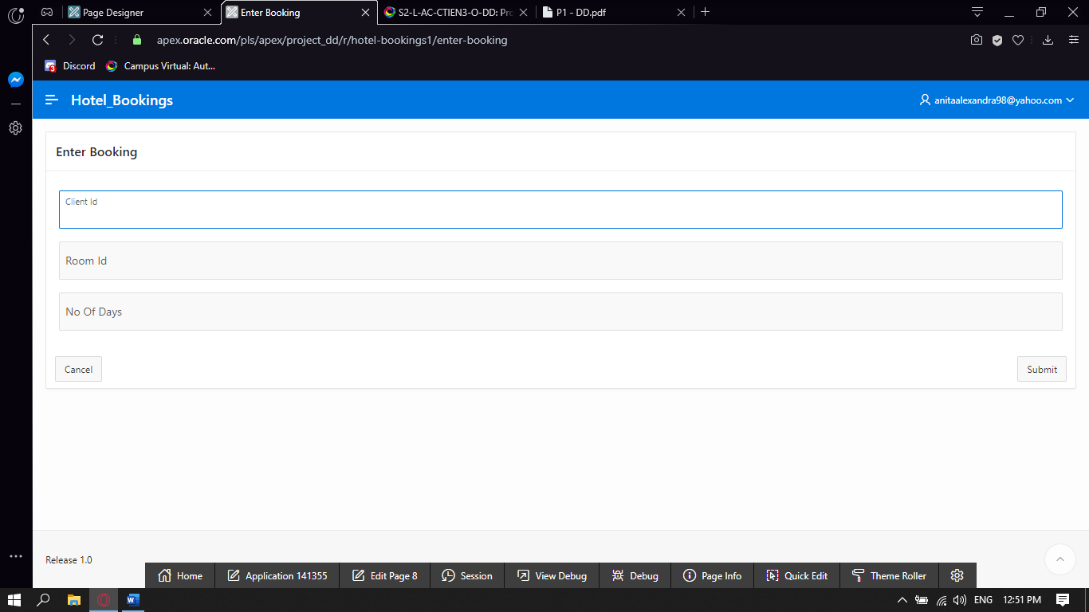

1. **Add an APEX form to input the information necessary to ending a reservation. This form will use this information to call the procedure for accommodation ending.**

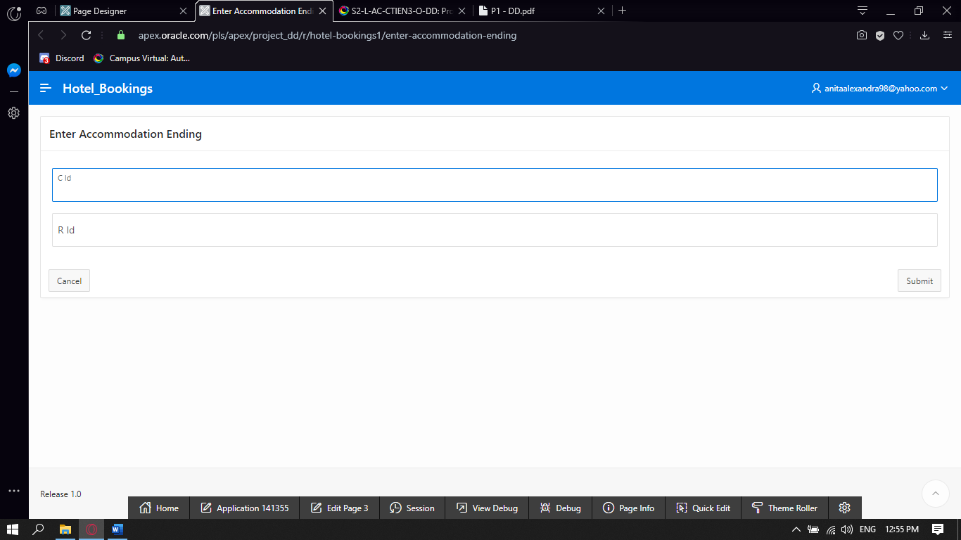

1. **Add an APEX report to list all rooms with information on actual occupancy of each room. The form will display also the number of overall free places.**

SELECT ID AS Room_ID,No_of_Places AS Total_Places,(select COUNT(*) FROM reservation Res WHERE Res.Room_ID=R.ID) AS Occupied_Places from room R;

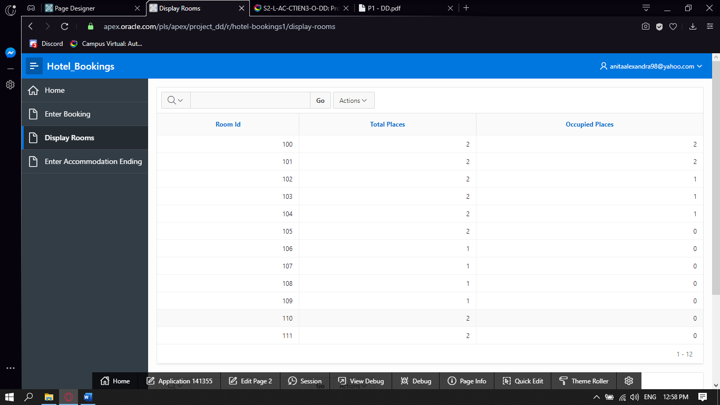

SELECT

(SELECT SUM(no_of_places)AS TOTAL_PLACES FROM ROOM) -

(SELECT COUNT(*) as TOTAL_RESERVED FROM RESERVATION)

AS Free_places

FROM DUAL;

